Results of work done with CellModeller from 20-2-18 to 26-2-18

Experiment 1. a. Staph.Aureus Growth(length=0.8micrometer) - 117208 cells in 3.64 hours

Drag=0.943 mg/s , Density(fluid)=1.0039 g/ml, Flow velocity(cell)=0.02mm/s, Drag Coefficient=0.47 , Reference Area=10000sq.mm

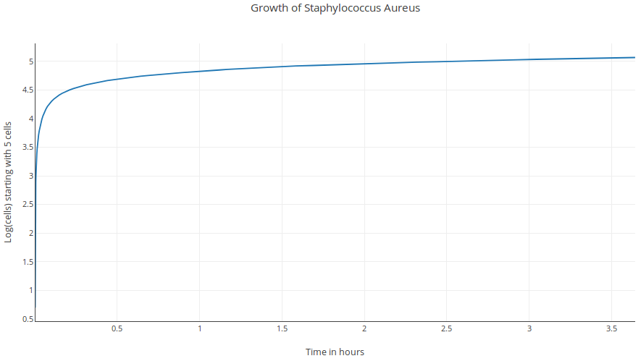
1. b. Staph.Aureus Growth(length=0.8micrometer – same as 1.a.) - 995 cells in 23.16 seconds

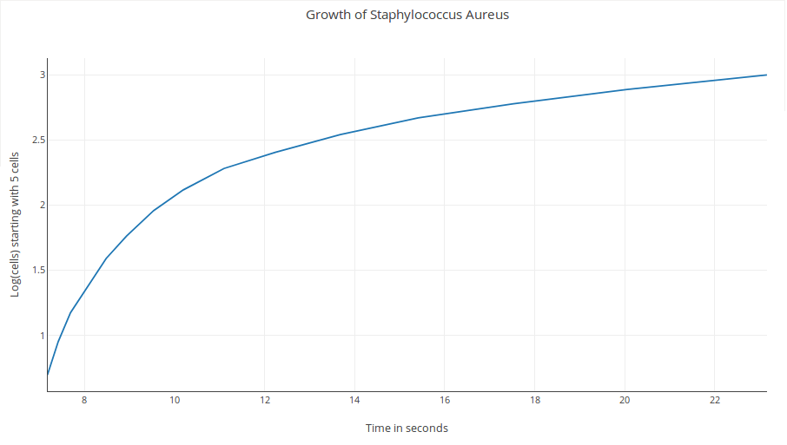

Experiment 2. a. E.Coli Growth(length=2micrometer) - 119629 cells in 1.70 hours

Drag=2.933 , Density(fluid)=1.105 g/ml, Flow velocity(cell)=0.03mm/s, Drag Coefficient=0.59 , Reference Area=10000sq.mm

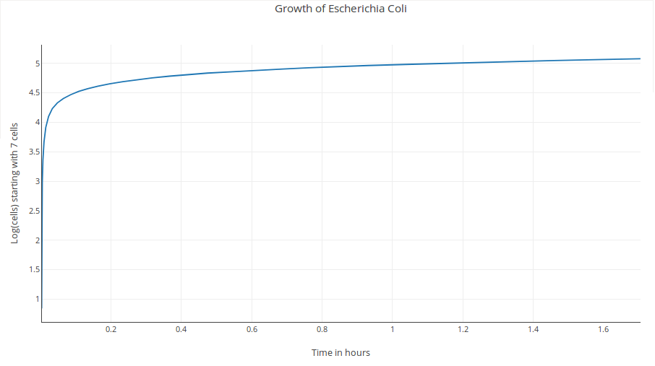
2. b. E.Coli Growth(length=2micrometer – same as 2.a.) - 2275 cells in 24.12 seconds

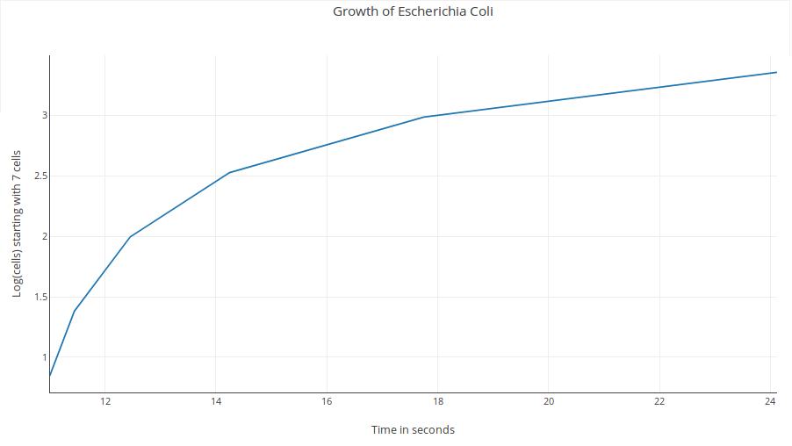

Experiment 3. a. Staph.Aureus(length=0.8micrometer) growth rate speeded up to equal E.Coli's drag
– 117158 cells in 2.04 hours and 129981 cells in 2.59 hours

Drag=2.933 , Density(fluid)=1.0039 g/ml, Flow velocity(cell)=0.03526mm/s, Drag Coefficient=0.47 , Reference Area=10000sq.mm

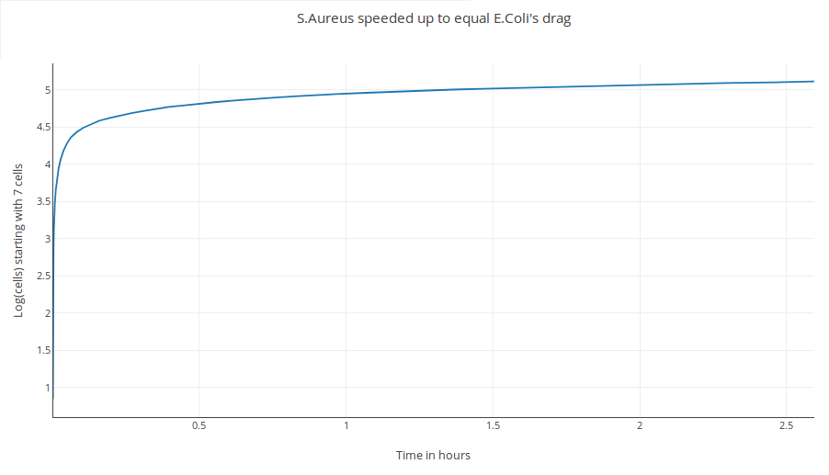
3. b. Staph.Aureus(length=0.8micrometer) growth rate speeded up to equal E.Coli's drag
– 2039 cells in 22.42 seconds

